**Dr. KALAIGNAR GOVERNMENT ARTS COLLEGE**

**KULITHALAI – 639120**

**DEPARTMENT OF ELECTRONICS**

**NAAN MUDHALVAN – SMART BRIDEG PROJECT**

**PROJECT TITLE : A CRM Application for Schools/Colleges**

SUBMITTED BY

TEAM LEADER : DHEENA.M (CB20S 274105)

TEAM MEMBER 1 : DHANABAL.V (CB20S 274104)

TEAM MEMBER 2 :  GURU PRAKASH.M (CB20S 274107)

TEAM MEMBER 3 : DINESHMOGIYA.R (CB20S 274106)

**INDEX**

S. NO CONTENT PAGE NO

1 INTRODUCTION 3

2 EMPATHY MAP 5

DZAAAAAA

3 ACTIVITY & SCREENSHOT 7

4 Trailhead Profile Public URL 18

5 ADVANTAGES & DISADVANTAGES 18

**INTRODUCTION**

**Salesforce is a modern cloud computing technology, which is available on cloud, no need to install any software as well as no hardware required. You can develop our own applications as well as need any application on demand and then you can buy from app exchange. App Exchange is a market place to sell our custom applications as well as to buy applications from app exchange easily Salesforce is a leading CRM (Customer Relationship Management) software which is served form cloud. It has more than 800 applications to support various features like generating new leads, acquiring new leads, increasing sales and closing the deals. It is designed to manage the organization's data focused on customer and sales details. It also offers features tocustomize its inbuilt data structures and GUI to suit the specific needs of a business. More recently, it has started offering the IOT (internet of things) connectivity to the CRM platform.**

**The design and implementation of the system is to provide service in institute and colleges. College Staff uploads attendance, results, share subject notes and college notifications through a secure, online interface using Salesforce. All data will be stored on the Salesfoce cloud managed by the college Administrator. This system will decreases the paperwork and time needed to access student records. Previously, college relied heavily on paper records for this initiative which had it’s own disadvantages. This system provides a simple interface for the maintenance of student information. Achieving this objective is difficult using a manual system as the information are scattered, can be redundant and collecting relevant information may be very time consuming. Our proposed system ensures to overcome these limitations. There is another part which is feedback, the student can give the feedback at anytime from anywhere to faculty. This feedback can be reviewed by the admin or the management committee of the institute through which the confidentiality of the feedback of the faculty can be maintained. This application is developed for daily student attendance in colleges and institutes. The teachers can send the attendance summary and feedback about the students to their parents. It can also be useful in an organization or company at a certain limit not the whole application.**

**OVERVIEW :**

* **Build a lightning app, add tabs and customize page layouts.**
* **Create custom objects and fields for the app.**
* **Define relationships between objects.**
* **Import data and test the app.**

**EMPATHY MAP**

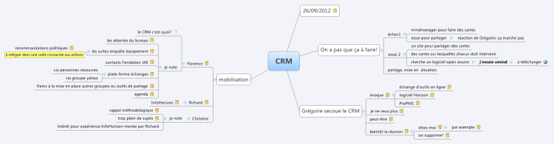

**BRAIN STORMING MAP**

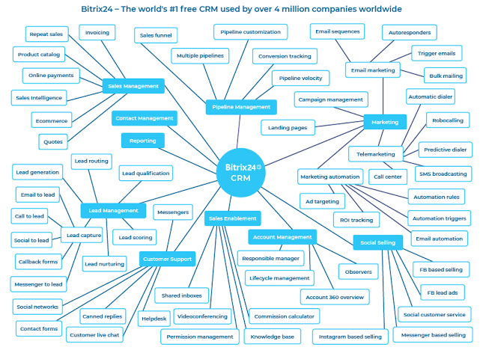

**Milestone 1 – Create Salesforce Org :**

Creating Developer Account Creating a developer org in salesforce. 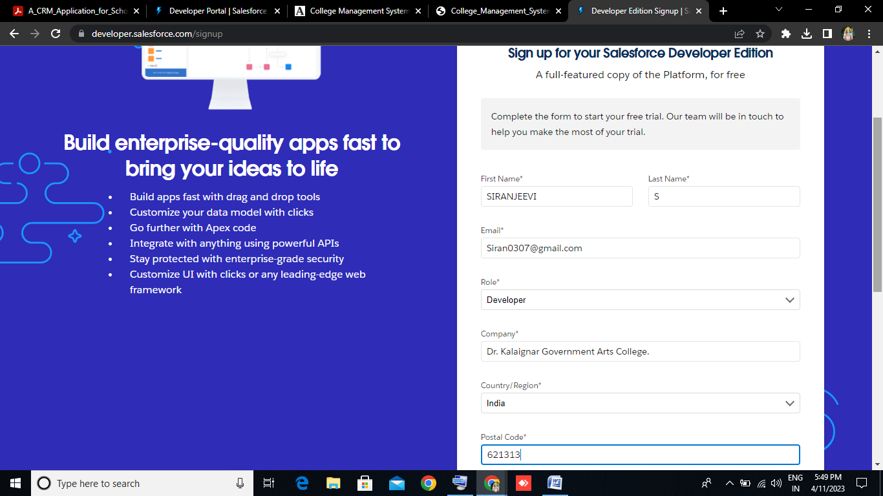

Account Activation 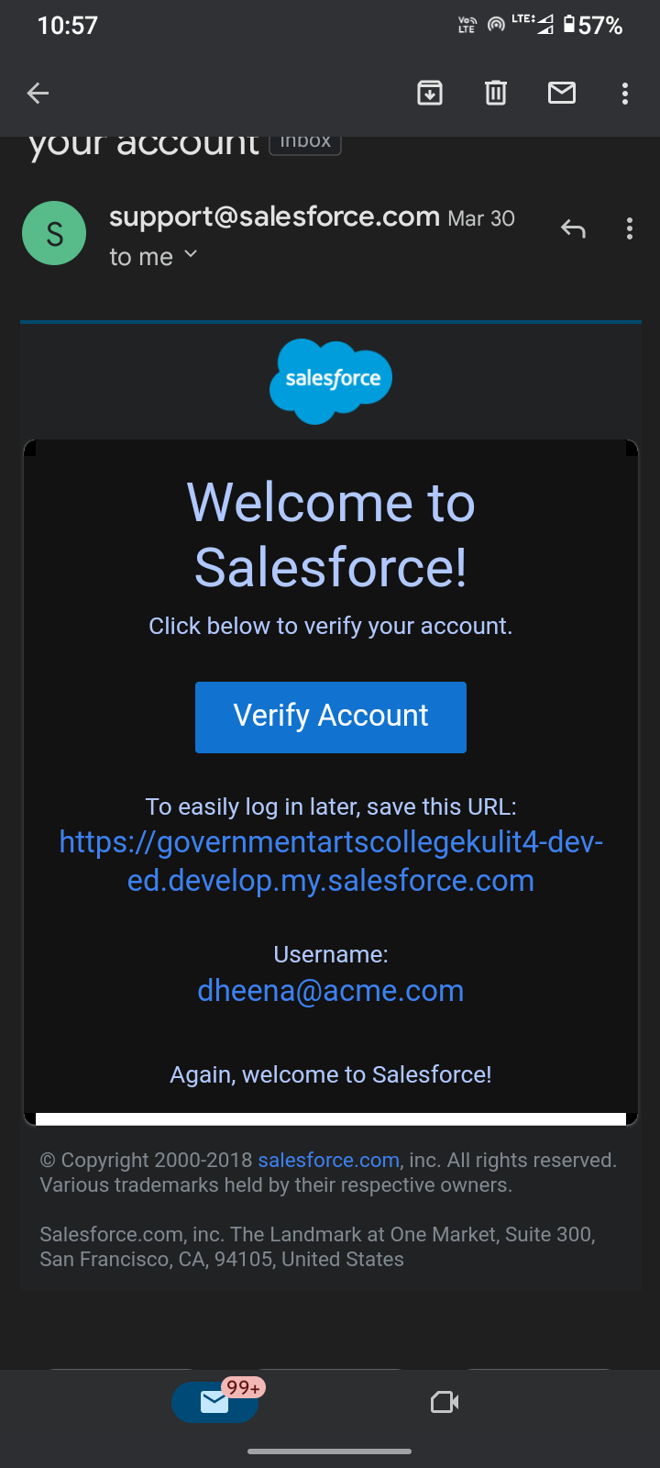

**Milestone – 2 : Object**

**Activity – 1 : Creation of School Object**

For this school management we need to create 3 objects i.e school,parents and students. The below steps will assist you in creating those objects.

This picture belongs to School object.

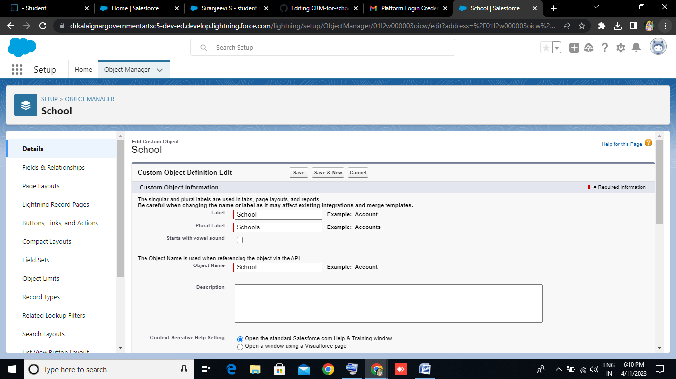

**Activity 2 : Create Student Object**

This picture belongs to Students object.

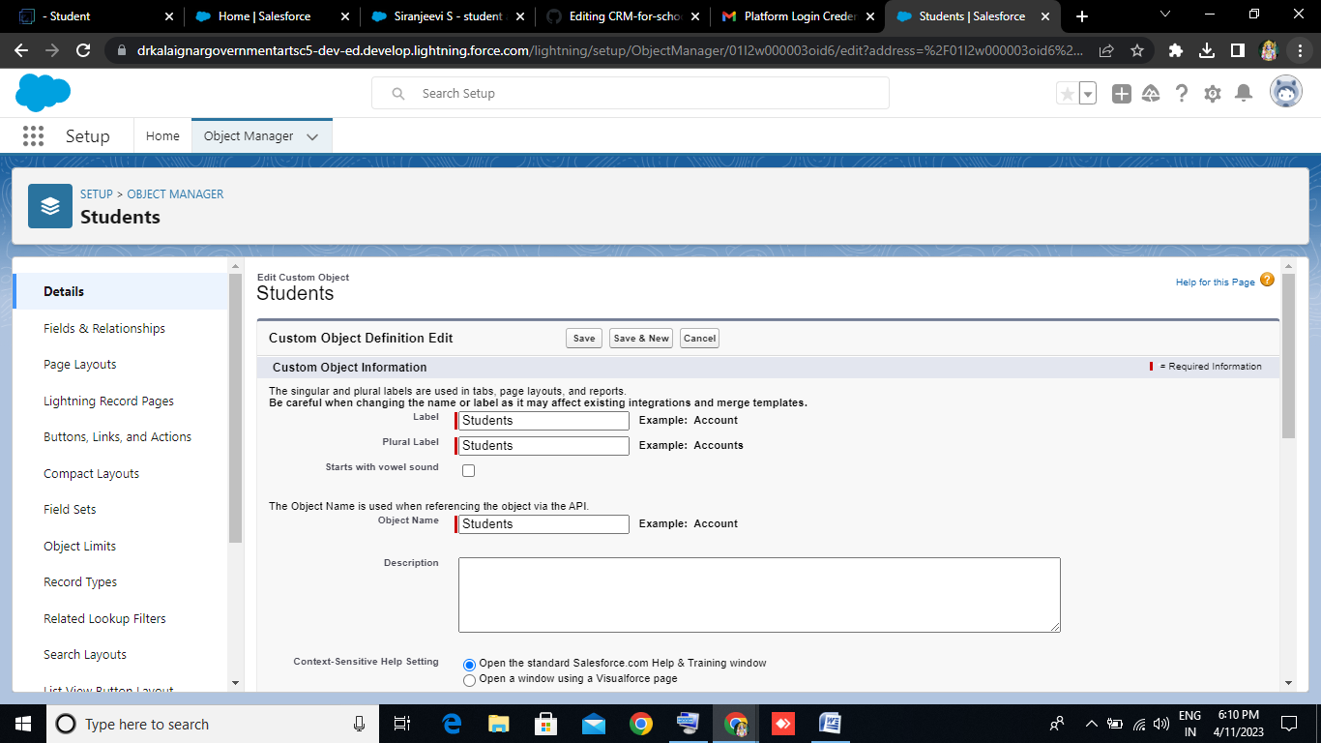

**Activity 3 : Create Parent object**

This picture belongs to School object. 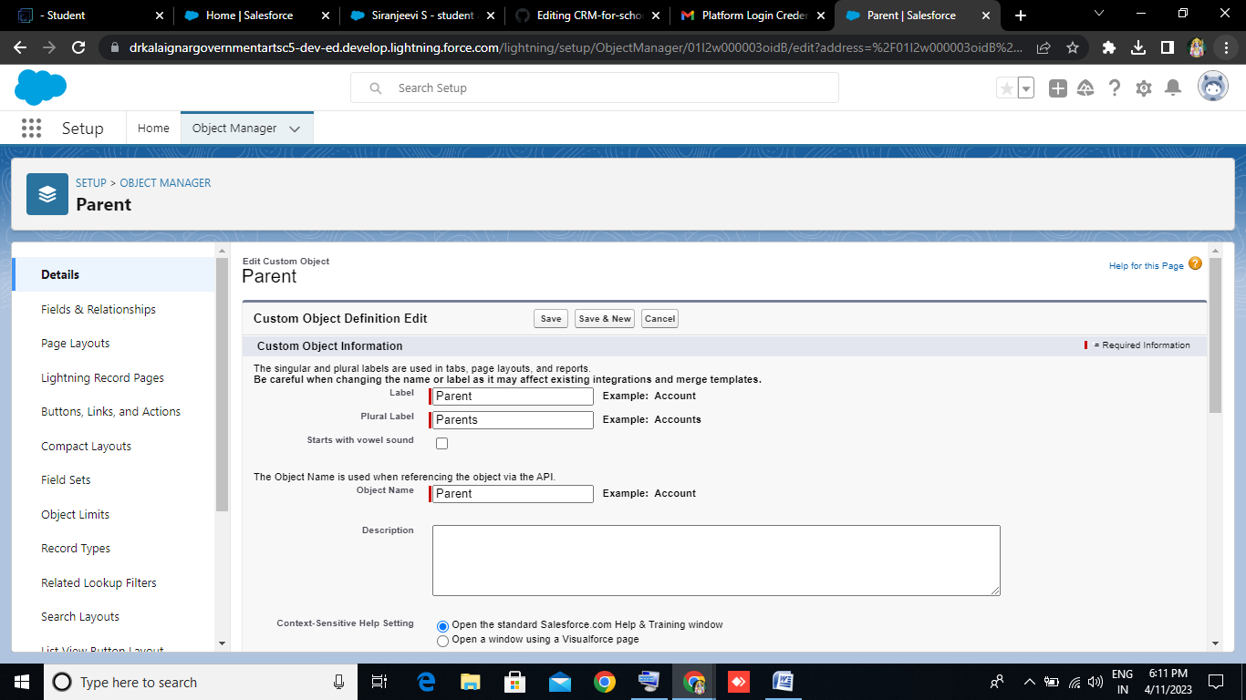

**Milestone -3 : Lightning App**

Apps in Salesforce are a group of tabs that help the application function by working together as a unit. It has a name, a logo, and a particular set of tabs**.**

**Activity:**

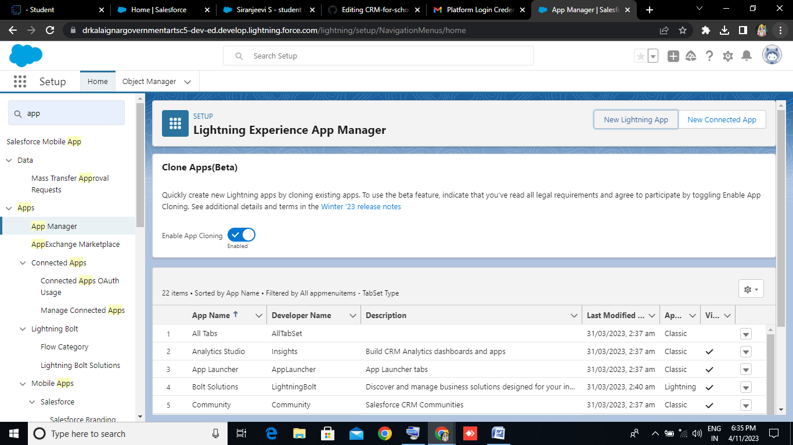

**Create the School Management app**

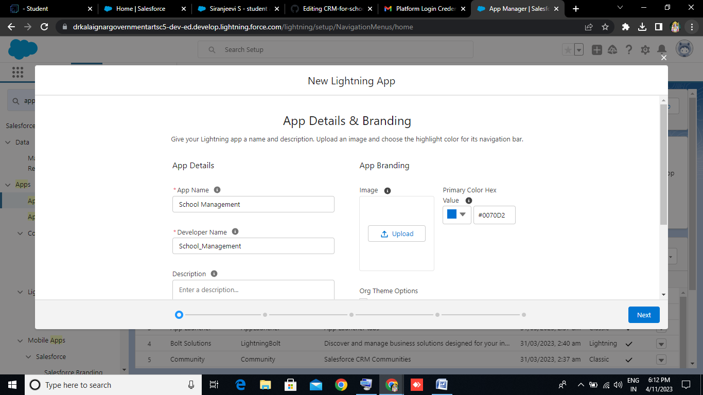

**Milestone -4 : Fields and Relationship**

**Activity – 1 :**

This is belongs to Fields & Relationship for School objects.

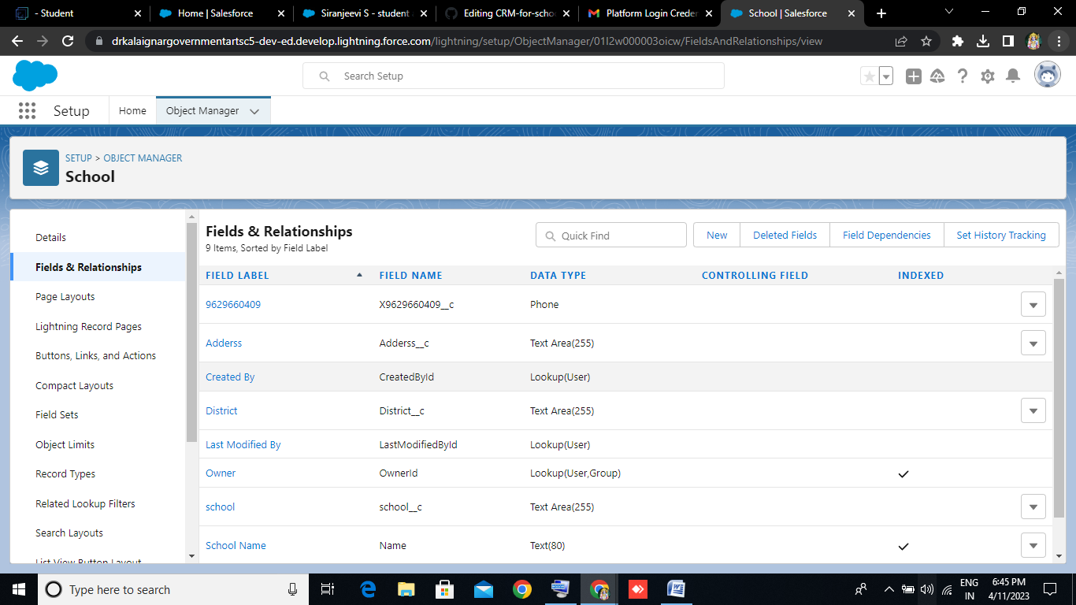

**Activity – 2 :**

This is belongs to Fields & Relationship for Students objects.

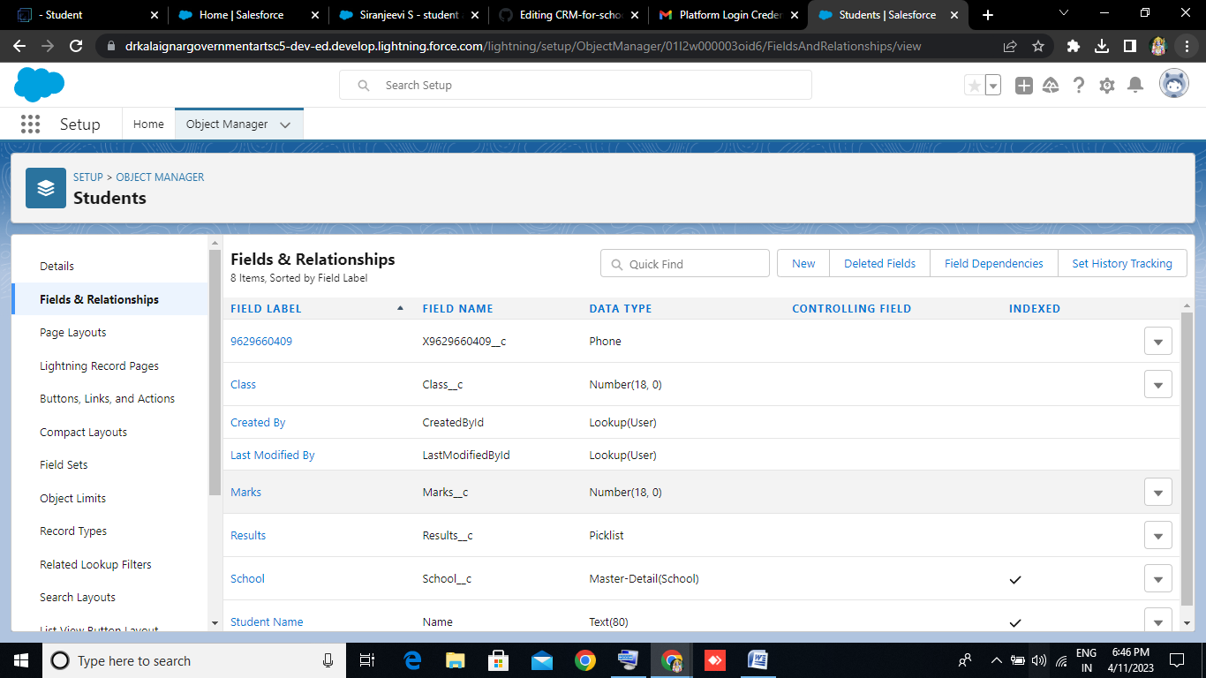

**Activity – 3 :**

This is belongs to Fields & Relationship for the Parents objects.

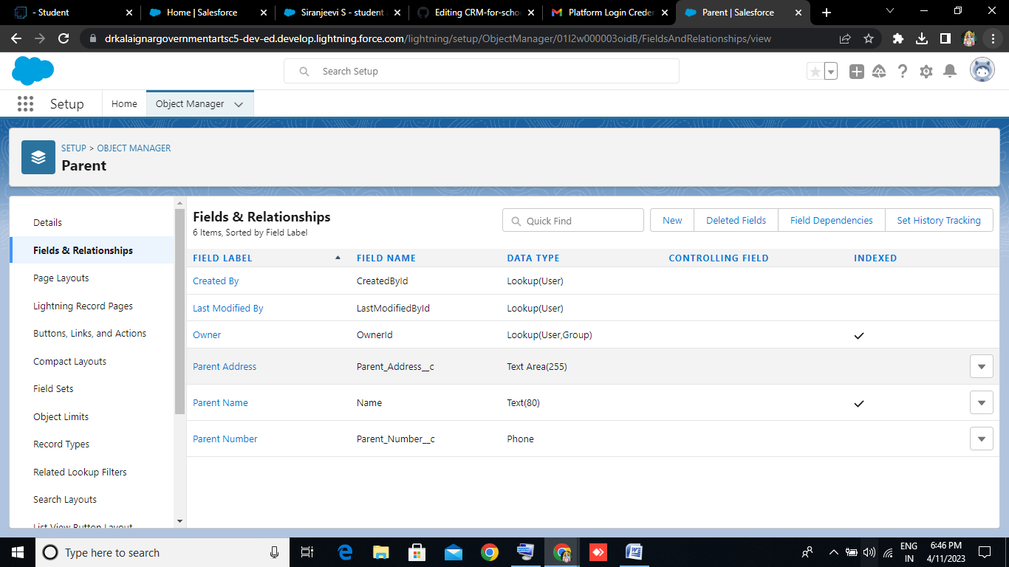

**Milestone -5 : Profile**

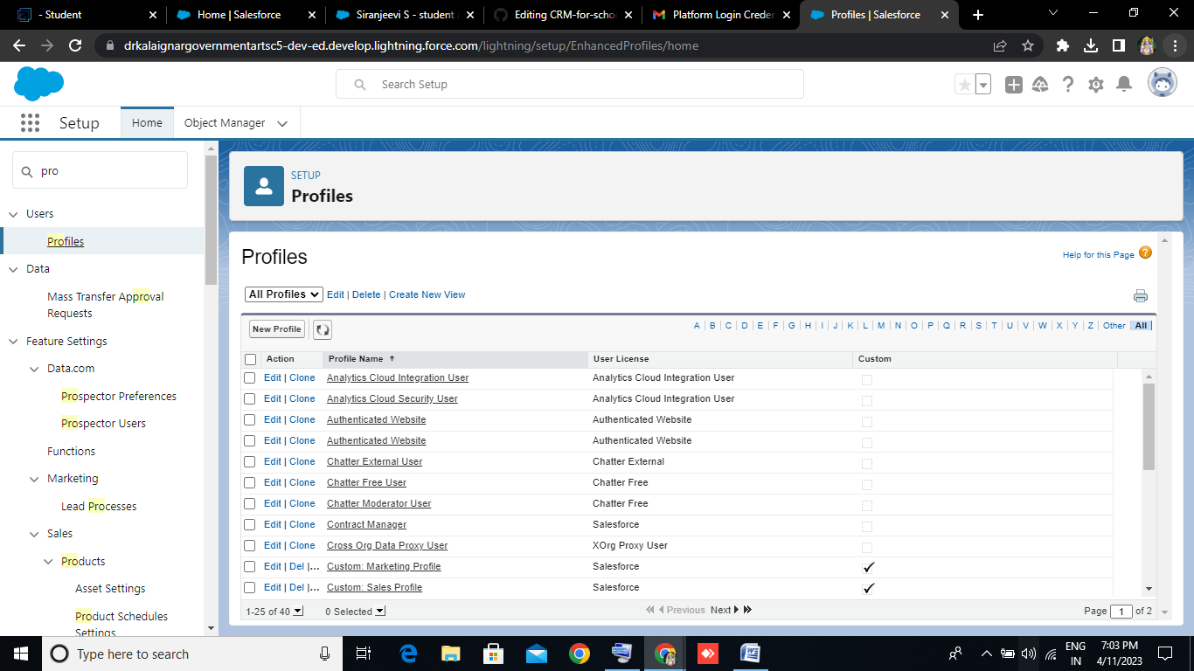

**Creation on Profile :**

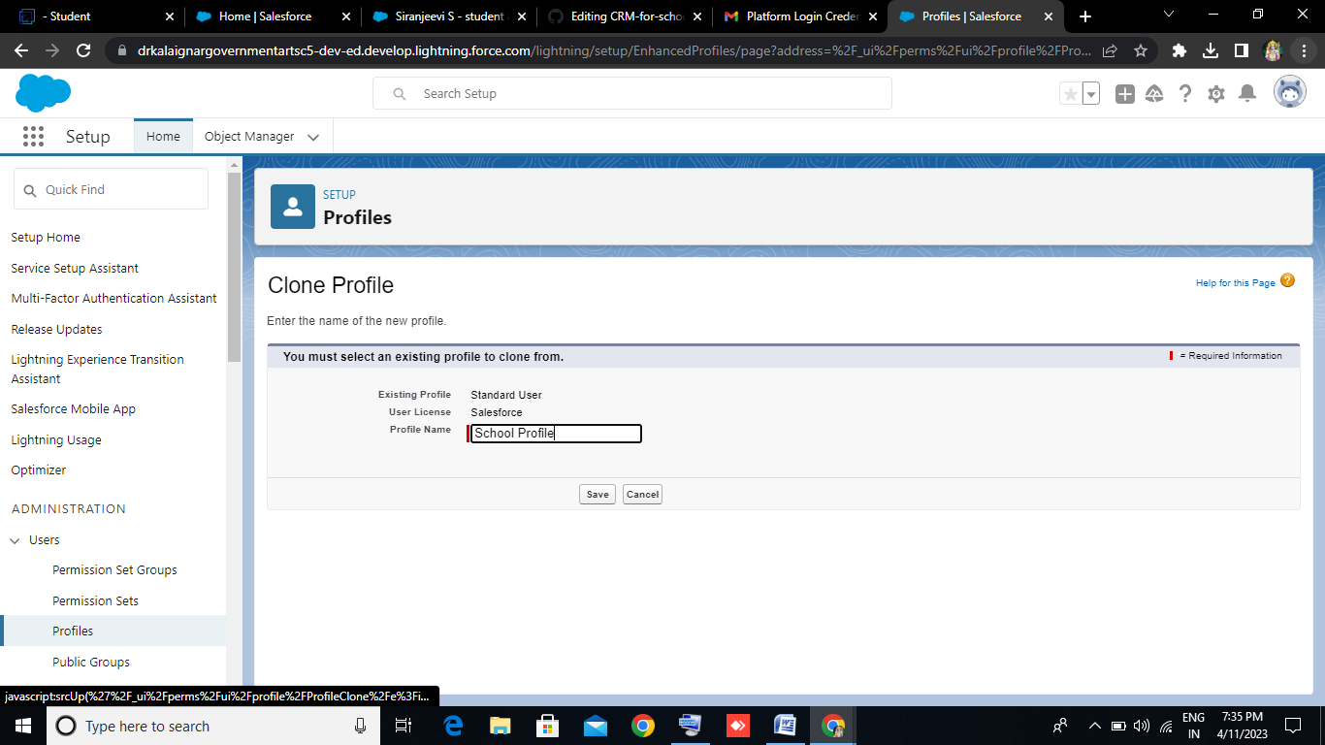

**Milestone - 6 : Users**

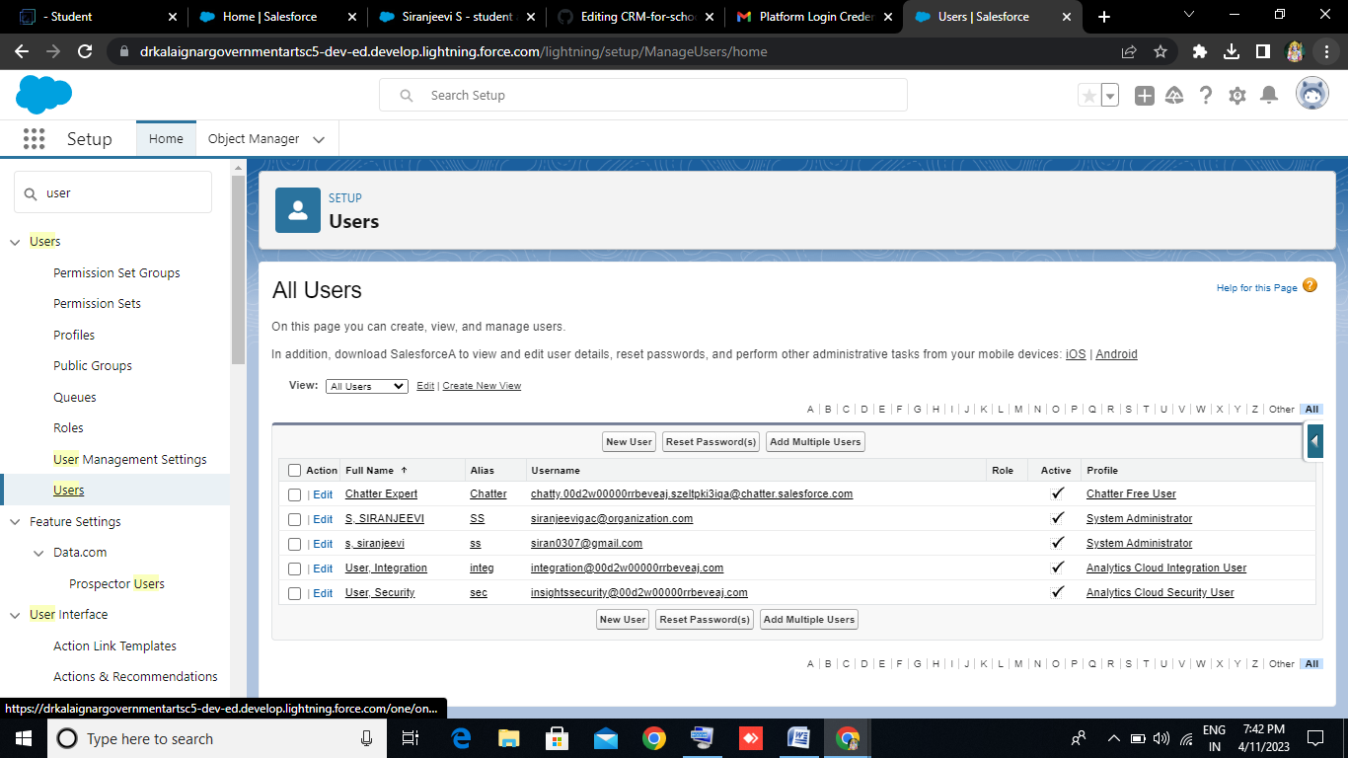

**Creating a Users :**

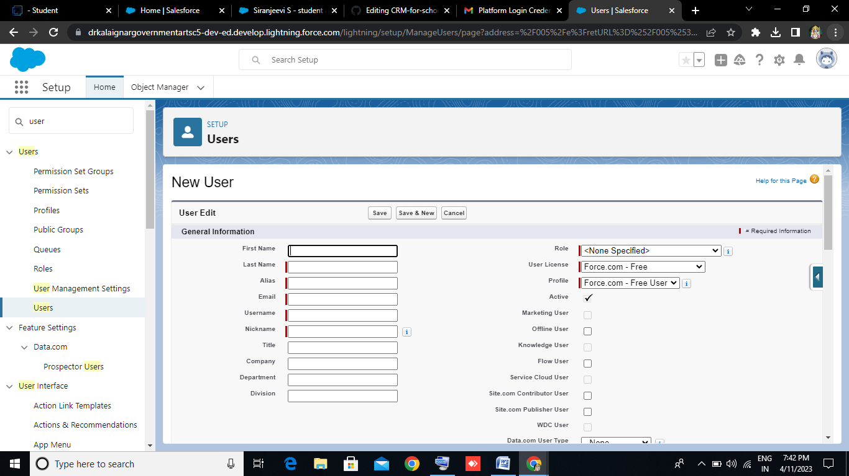

**Milestone - 7 : Permission Sets**

**Activity – 1 :**

**Permission Sets 1 :**

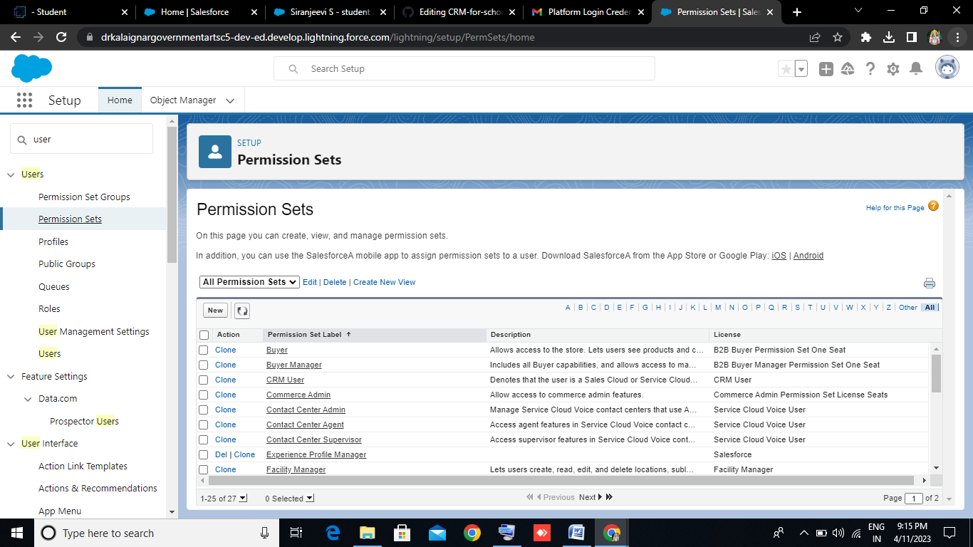

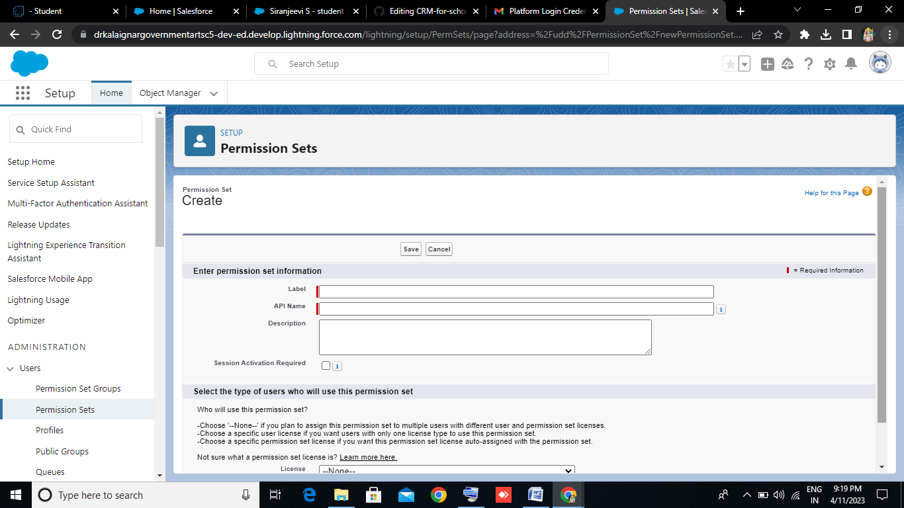

**Activity – 2 :**

**Permission Sets 2 :**



GIve the name of the Permission set name as Principal permission and then under the object settings give all permissions for the custom objects and assign them to the Principal user.

**Milestone - 8 : Reports**

**Activity :**

A report is a list of records that meet the criteria you define. It's displayed in Salesforce in rows and columns, and can be filtered, grouped, or displayed in a graphical chart. Every report is stored in a folder. Folders can be public, hidden, or shared, and can be set to read-only or read/write.

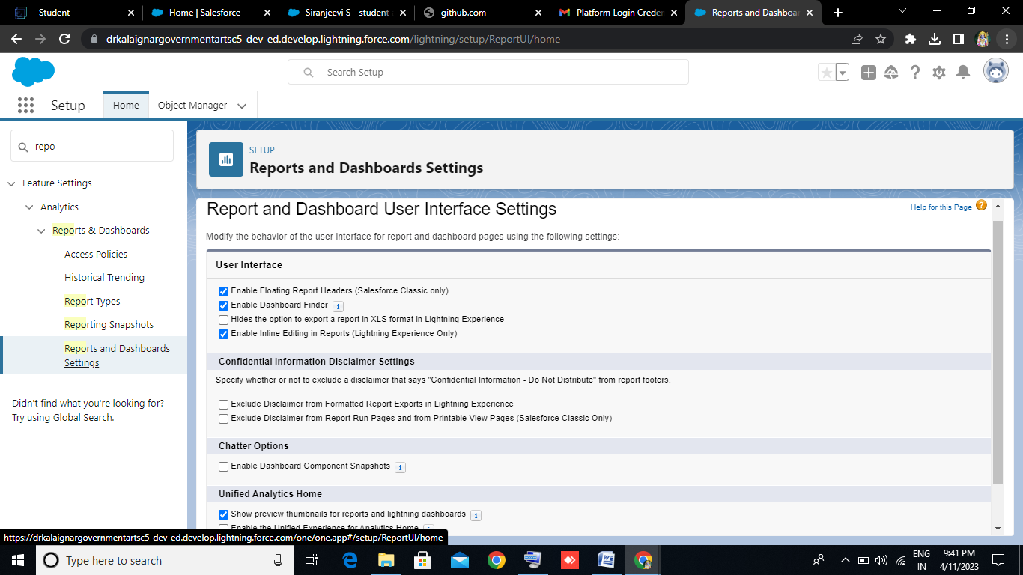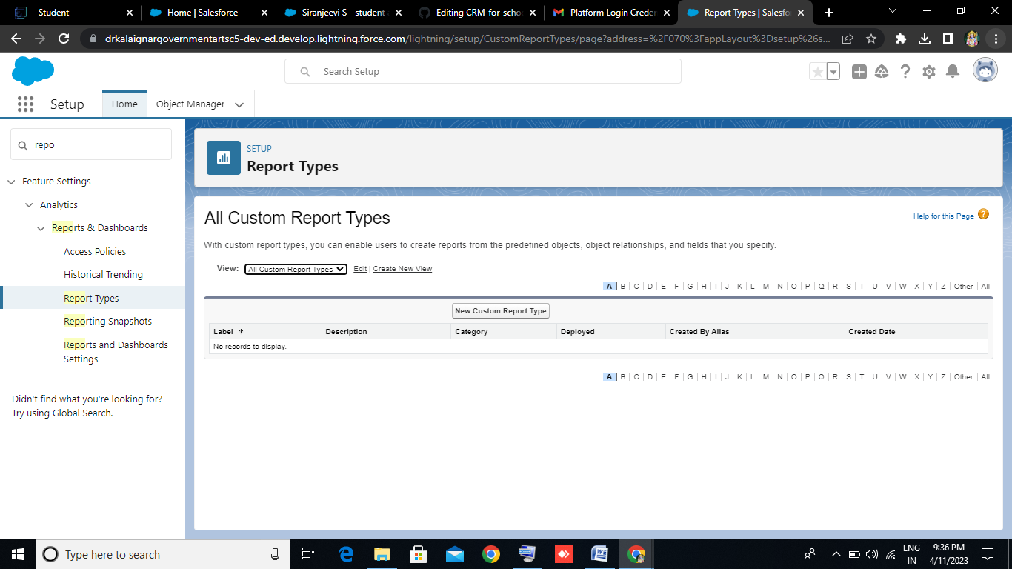

**Trailhead Profile Public URL**

Team Leader - https://trailblazer.me/id/dh93

Team Member 1 - https://trailblazer.me/id/dhvvd

TeamMember 2-https://trailblazer.me/id/mguruprakash

Team Member 3 - https://trailblazer.me/id/rdinesh32ADVANTAGES**S & DISADVANTAGES**

Remember how businesses used to store customer information? In telephone books, Excel tables, diaries, card files. It was uncomfortable. All these carriers could be lost at a moment, and it was quite difficult to organize information in them or find it quickly. It was possible to restore the entire history of relationships with the client only from memory or by collecting all the records together.

Almost the same approach was used in education. The methodologists manually drew up timetables, all information about the students was stored in journals, and the educational process itself could not be imagined without a physical presence in the classroom. Fortunately, those days are over.

For everything to run like clockwork and to run quickly, it is necessary that information about each student and teacher be entered into a common database. In this case, the search for it should be fast, and the updating of information should be simple. All work tasks and timetables should also be kept in a convenient form and be easily available and modifiable at any time. All these functions and many others are implemented in modern CRM for the education industry.

CRM for higher educational institutions are customer relationship management systems. They include other functions for optimizing business processes - you can find everything you need. It all depends on the needs of the company.

CRM usage in higher education has a wide range of powerful benefits. All processes, both educational and any others, must be recorded in a single information space, otherwise chaos cannot be avoided. Importance of CRM systems in higher education lies in:

* Customer accounting and complete information about the relationship with them;
* Marketing tools;
* Schedule of classes and information on the educational process, by student;
* Personal accounts of students and teachers with the ability to upload homework and receive feedback;
* Ability to create tasks, business processes and schedule work.

This is not a complete list of features that prove efficiency of CRM in managing students. There may be other functions, including non-standard ones, for the implementation of which developers can be involved.

The development of the online learning business is going fast these days and the competition for the consumer has become very intense. Many companies are no longer able to reduce their rates to attract customers - all that remains is to compete on the basis of quality indicators, including improved customer service and improved service levels. And this is just the area of ​​CRM.

The CRM approach has a great future and advantages of CRM for educational organizations are undeniable. Advertising was once considered the engine of commerce. Today it is not enough to create an original course, it must be customized, adapted to the needs of a particular individual. CRM allows you to close the entire cycle by "correct" work with the client. A company that has mastered CRM technology will be able to outstrip its competitors.